Experiment no.1
Study and analysis of DC Motor, Potentiometer and interface modules.
Objectives:
- To understand the analog features of DC motor, input potentiometer and interface modules.
- Connect the modules for analog control study.
- Analyze the software control to drive DC motor and observe the output.
Lab equipment:
- MS15 module.
- AS3 command potentiometer.
- Control Laboratory input/output interface (CLIO).
- Power supply.
- Connecting leads.
- Virtual control Laboratory (VCL) software.
Theory:
To study the behavior of DC Motor, potentiometer and different interface modules, it is essential to perform the practical exercise on hardware and to analyze different waveforms displayed on the PC.
A PC with the virtual control laboratory software and CLIO control Laboratory Input/output interface is used to replace a number of different traditional instruments, eliminating the need for separate signal generator oscilloscope, multi meter or controller.
In this first experiment, you will refresh your knowledge of the DC motor which is used as the PLANT and familiarize yourself with the interface board and the operation of the software.
A trainer or collection of components are used(analog and digital) in this experiment are MSI5 module, DC motor, tachogenerator, plant input, velocity output, position output, motor controller, amplifier, potentiometer, tachometer, signal conditioning block and virtual software.
Wiring diagram of MS15 module is shown in Fig.1.
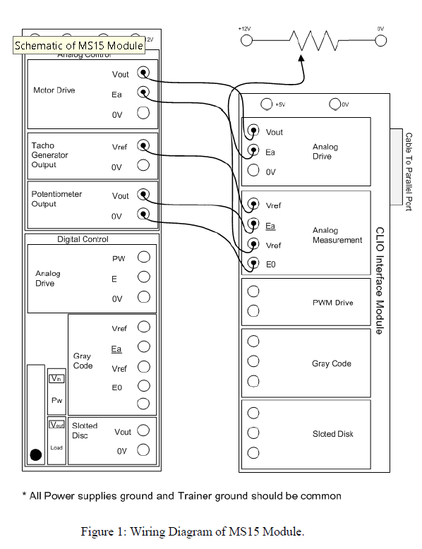

Procedure:
In this experiment fundamental principles of analog and digital motor control will be studied. This includes a DC motor control module, command potentiometer, windows based control software, input/output interface module, power supply unit and connection leads. This curriculum makes use of real-time Windows ™ based virtual control laboratory software (I will recommend to watch this video Real-Time Simulation and Testing with Simulink Real-Time - YouTube) and control laboratory input/output (CLIO) interface module which enables the student PC workstation to:

